Basic Calculus | 3rd Quarter
PeTa: Trigonometric Functions and Limits
February 7 2021

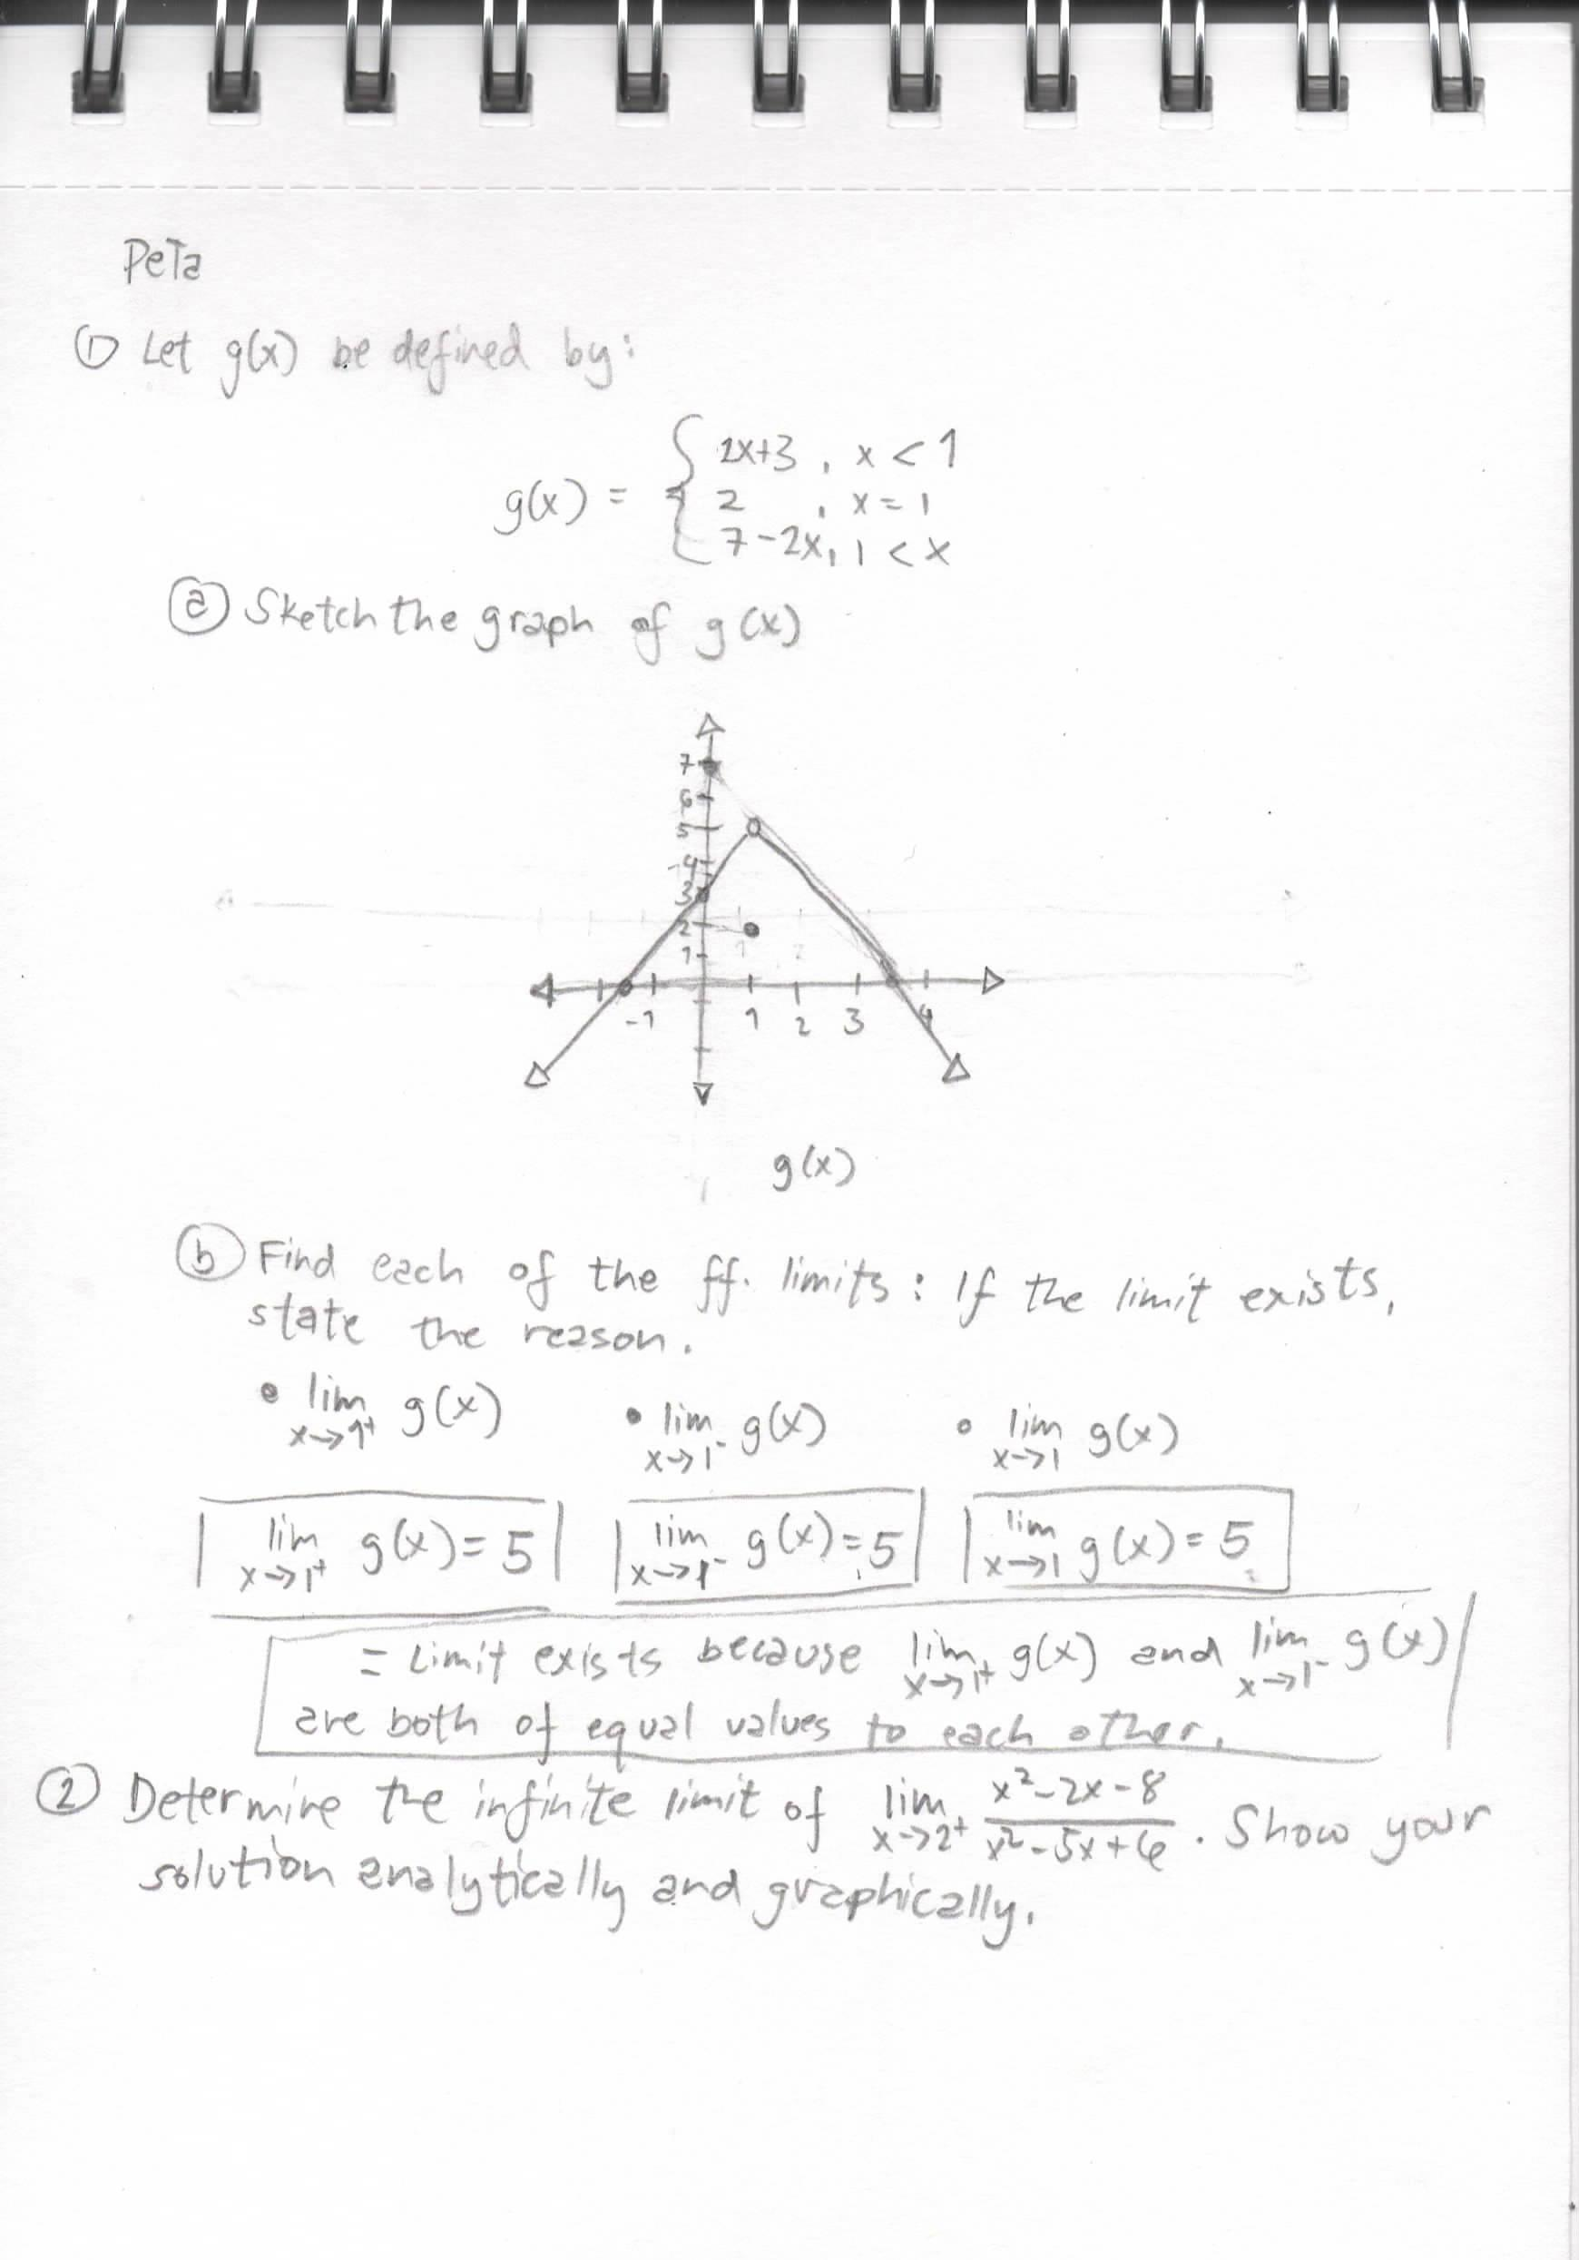 | 